Year 7

Term 4 Test

Name: ______________________ Class: ______ Time: 50 minutes Total Mark:____/58

Show working and answers on this sheet. Show working in sufficient detail to support your answers. Incorrect answers without supporting reasoning will be allocated zero marks.

Resources: 1 A4 page of notes (1 side), Calculator allowed, Protractor, Ruler.

Question 1 2 marks

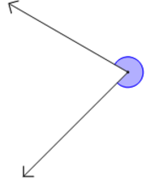
Using a protractor measure the size of the following angles:

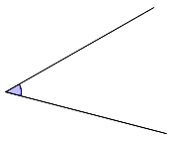
- b)


Question 2 4 marks

Identify the type of angle in the following:
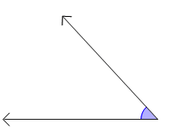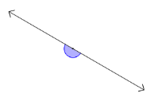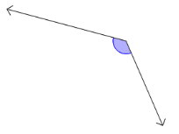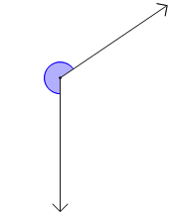

- ______________ b) _______________ c) _______________ d) _________________

Question 3 1 marks

Which of the following does not have two sets of equal sides?

- Rectangle b) Kite c) Trapezium d) Parallelogram

Question 4 7 marks

Find the value of the unknown number:
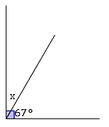
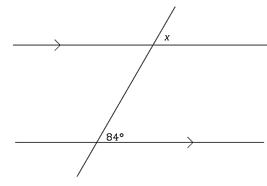
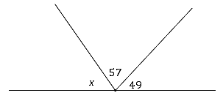
- b) c)

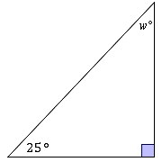
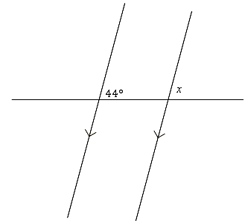
d) e)

Question 5 4 marks

Determine whether the lines AB and CD are parallel. Justify your answer.
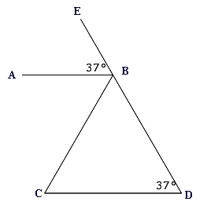
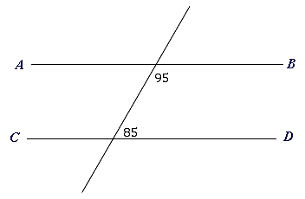
a) b)

___________________________________ ___________________________________

Question 6 2 marks

Write the following as a percentage:

- 4 out 12 b) 27 out of 42

Question 7 2 marks

Calculate 45% of $450:

Question 8 3 marks

A mixed netball team has 4 boys and 5 girls:

- Express these numbers as a ratio.

- A new girl joins the team. What is the new ratio in simplified form?

Question 9 3 marks

An 18 carat gold ring is made of 18 parts gold and 6 parts alloy metal. How much gold is in a ring that weighs 84 grams?

Question 10 2 marks

Ryan earns $62.80 in 4 hours of work:

- What is his hourly rate?

- How much money would she earn if she worked for 7 hours?

Question 11 2 marks

Rewrite the following word equations using symbols:

- When a number is subtracted from nine the answer is seven. ______________________________

- When a number is tripled and then twelve is added. ______________________________

Question 12 4 marks

Solve the linear equations showing clearly the method used:

- $x+4=15$ b) $\frac{y}{2}=3$ c) $\frac{3x-1}{4}=5$

Question 13 3 marks

Determine whether each of these graphs is either linear or non-linear:

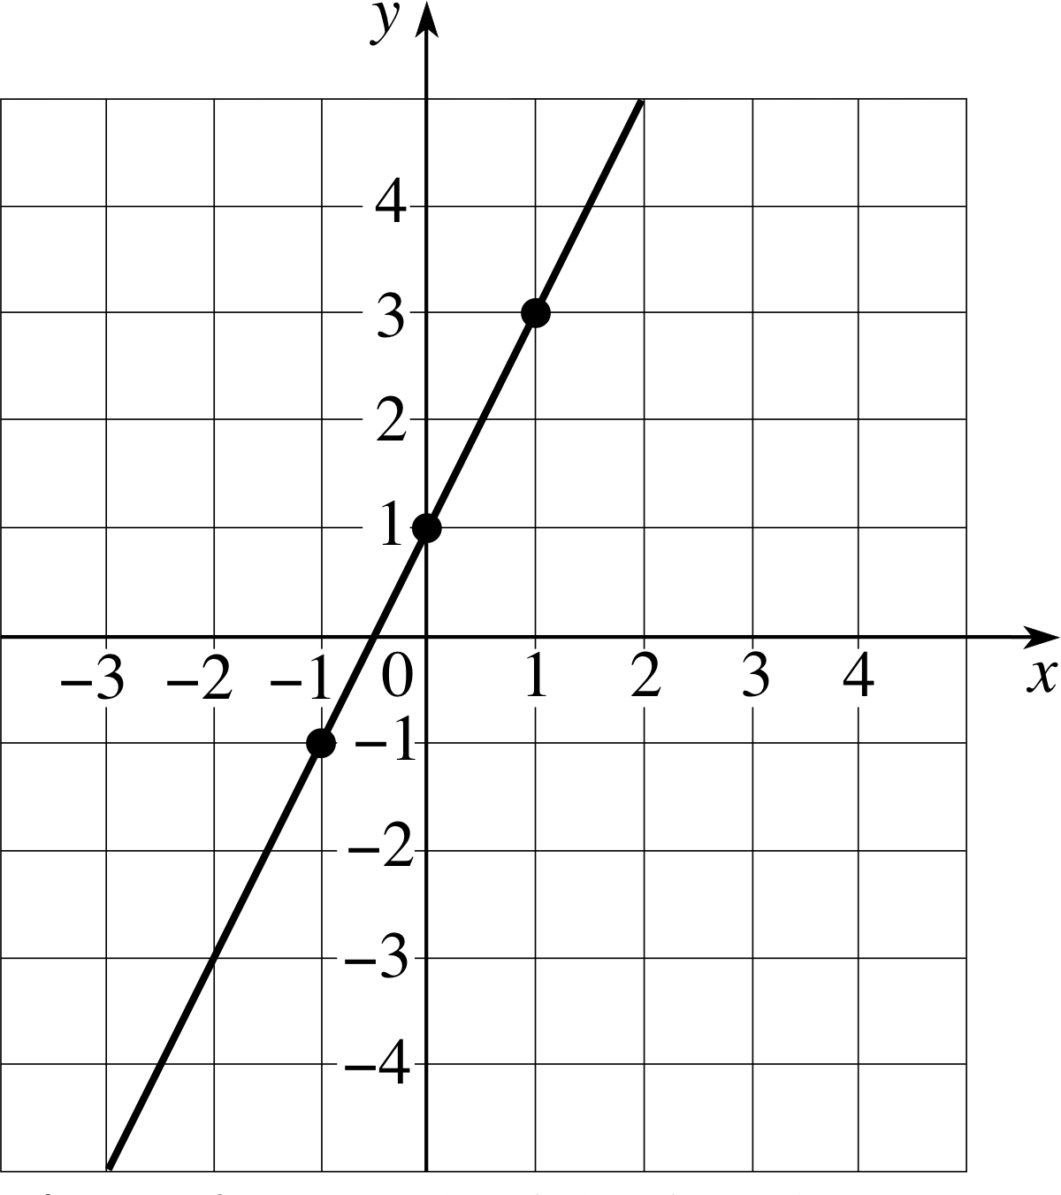
- b) c)
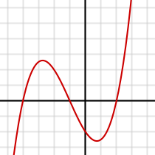
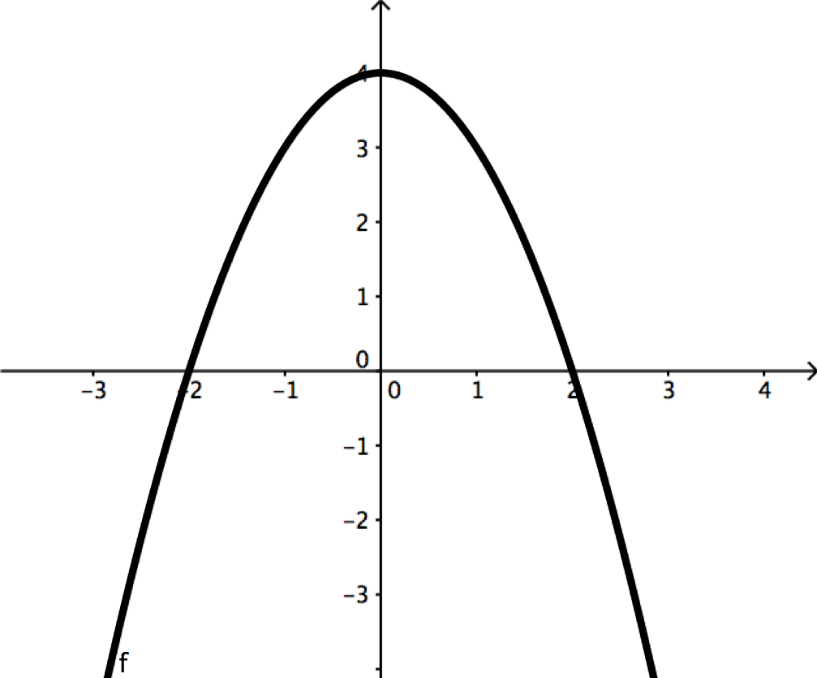

_________________ __________________ __________________

Question 14 8 marks




For the following function: $d=2t+2$, where t is the time in minutes and d is the distance in kilometres:

- Complete the table.

- Label the axis, plot the points and draw the graph.

- Is it a linear equation?

- What is the distance travelled after 4 minutes?

Question 15 8 marks

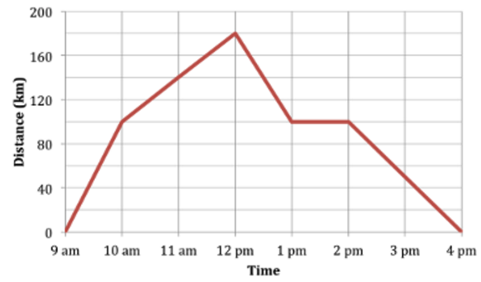
The travel graph above shows Sue’s journey in her delivery truck. She starts her morning at the depot and travels to Bunbury to drop off some goods at the warehouse (Bunbury is 180km from her depot).

- At what time does she leave the depot?

- What time does she arrive at the warehouse in Bunbury?

- How long was the entire journey?

- On her way back Sue decided to stop in Myalup for lunch. How long did she stop for?

- At what time in her journey was she driving the slowest? Justify your answer.

- Calculate her average speed from the depot to Bunbury.

Question 16 3 marks

The price of hiring a painter is given by the function $d= 30t+100$ , where t is the time in hours and d is the price in dollars:

- What is the charge for a painting job that takes 5 hours?

- Find the time for a painting job that costs $400?

END OF TEST

